Square Deal Weave-Along #18—Leno, Part 2: LET’S DO THE TWIST
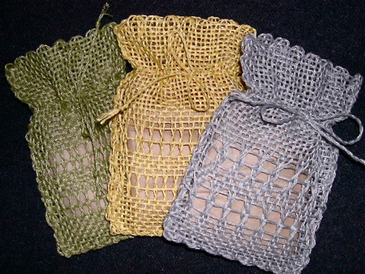
These soap bags, made with Euroflax sportweight linen on the 4”x6” Weavette loom, are fun and easy to make. They are a great vehicle for experimenting with patterned weaves. Two rectangles are joined by a running stitch on three sides. (Pull out enough yarn at the beginning of one rectangle to sew the seam.) I use a battery-powered hair braider to twist the cords. Overtwist two individual strands and then ply the opposite direction. It can be done by hand but the hair-braider does it in a fraction of the time.
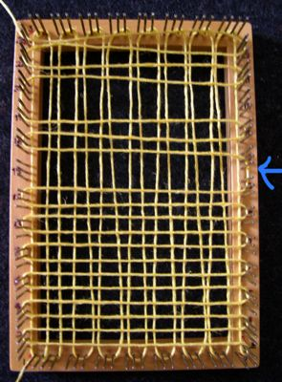
If you haven’t already experimented with adding length to warp, do that before attempting leno lace on small looms. It shows up best in a stiff yarn like linen or hemp and the twist looks nicer if the warp is somewhat relaxed. At the same time you’re adding length to the warp (vertical threads), skip a row of weft while wrapping the second layer (horizontal thread). I did this twice, skipping only one row at a time. You should wrap FIVE pins. I skipped rows 14 and 19. The blue arrow in the photo shows where I made a mistake and only wrapped four, but that was corrected when I started weaving. Skip an even number of rows total, which will allow your weft to end up in the correct place at the end. You could experiment with leaving only one strand between rows of leno. That works, too. Just a different look.
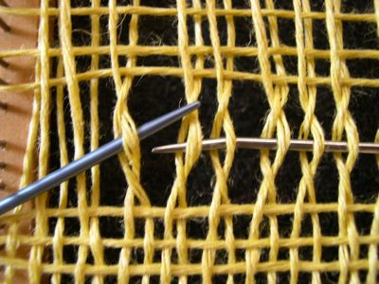
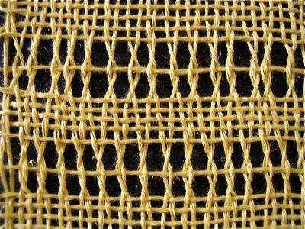
Weave plain weave up to the skipped weft section. Then use another needle or small knitting needle as a tool to pick up and twist two (or more) adjacent warp threads. From the right, use the tool to pick up a bottom warp thread; go over a the next top warp thread; rotate the back end of the tool 180 degrees to the left. What you see above is after rotating the tool. Slide the weaving needle into the space where the tool is; remove the tool and proceed across the loom. You may weave the first and last thread or two in a regular fashion, or not—whatever works for you.
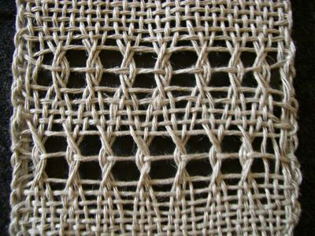
This example is double leno.
If you need more ideas and better illustrations for hand-manipulated leno lace, download the article by Karen Searle (middle of the page, under Minnesota Weaver) that I linked in the previous post.
WAL PARTICIPANTS LIST
I’m redoing the WAL list due to bad (or no) links and people moving on to other things. If you want to be listed (or relisted) with your link of weaving content, contact me and I’ll be happy to add you.

Square Deal Weave-Along #18—Leno, Part 1: ADD LENGTH!
Posted September 5, 2008 Comments(5)
…to your weaving warp on small looms that have no mechanical tensioning device. (As long as I have to deal with daily comment spam, I might as well have a bit of fun with it.)
Seriously, this odd technique may keep you from bending or pulling the pins out of your loom, or breaking your needle, and it will allow you to use some weaving techniques that would otherwise be impossible. I invented this “fix” while weaving leno lace with linen on a 4”x6” loom. Heck, I can’t even do 4″x6” plain weave in linen without this remedy. That’s to be expected. Linen has NO elasticity. Plus plain weave takes up more yarn than a patterned weave. You can always weave the weft looser, but what about the warp which is already on the loom and getting tighter with every woven row? Gotta add some length to that warp!
Here’s what I did. Begin as usual, but every time you wrap the warp around pins at the top of the frame, make an extra loop around one pin before continuing to the bottom of the frame. At the same time, keep the warp wraps (layers one and three) relaxed and loose. (Layer two, the first weft wrap, should be normal tension.)
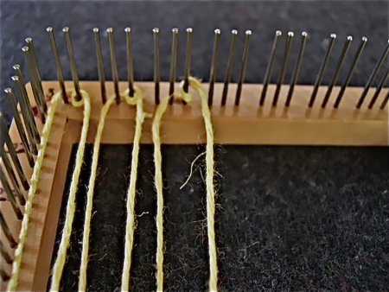
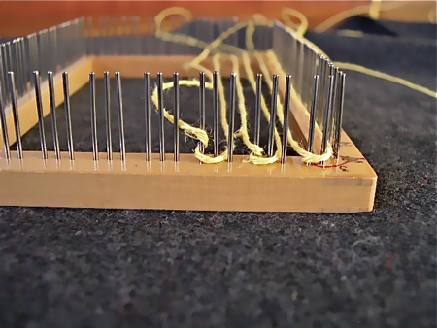
Photos above show first, the loom as you are looking at it while wrapping and second, from the top, to show how the loops look on the pins.
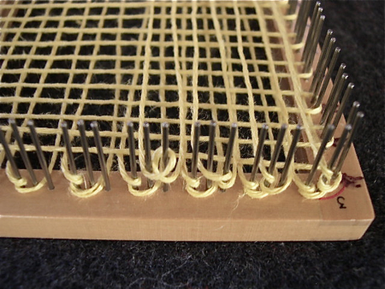
Photo above shows the third layer of yarn, illustrating how the loops appear at the top of the loom.
Measure yarn for weaving length and weave as usual to about half the length of the loom. By now the yarn is starting to get tight, and it’s time to unleash those extra loops at the top.
Anchor your weaving needle at the bottom. Keep an extra needle or double pointed knitting needle handy in case you need a third hand. Beginning at the upper right corner, lift off the last two top loops.
Rehang the bottom loop on its pins, then the upper one. This is exactly what you do when you accidentally lose some loops while weaving. Only on purpose this time.
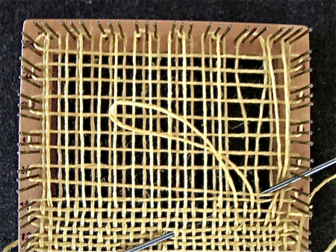
Work across loom in this manner, anchoring the loose loops with your needle if you worry about them popping off. Don’t forget that the very last loop, which goes around the corner, needs a loop before being repositioned. Look at it carefully before you remove it.
After another woven row or two, the newly loose loops will fall right into place and you’ll have enough warp length left to make the finish without pulling out the loom pins—or your hair.
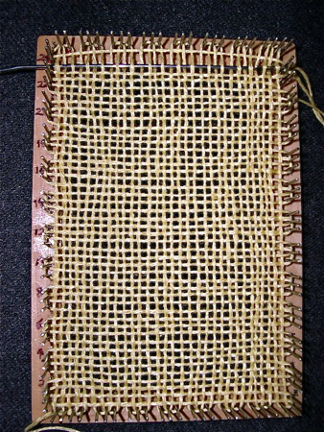
If you plan to weave leno with me on the next Square Deal Weave-Along posting, I seriously recommend that you practice this warp tensioning device first, using non-elastic cotton, linen or hemp.

